ADO .Net(Active Data Object):

It is Used to Connect Front-End(User-Page) and Back-End(Data base).

**Difference Between ADO & ADO.Net:**

|  |  |
| --- | --- |
| **ADO** | **ADO.Net** |
| **ADO is base on COM : Component Object Modelling based.** | **ADO.Net is based on CLR : Common Language Runtime based.** |
| ADO stores data in **binary** format. | ADO.Net stores data in **XML** format i.e. parsing of data. |
| ADO can’t be integrated with XML because ADO have limited access of XML. | ADO.Net can be integrated with XML as having robust support of XML. |
| In ADO, data is provided by **RecordSet**. | In ADO.Net data is provided by **DataSet** or **DataAdapter**. |
| ADO is **connection** oriented means it requires continuous active connection. | ADO.Net is **disconnected**, does not need continuous connection. |
| ADO gives rows as single table view, it scans sequentially the rows using **MoveNext** method. | ADO.Net gives rows as collections so you can access any record and also can go through a table via loop. |
| In ADO, You can create only **Client** side cursor. | In ADO.Net, You can create both **Client & Server** side cursor. |
| Using a single connection instance, ADO can not handle multiple transactions. | Using a single connection instance, ADO.Net can handle multiple transactions. |

5 Steps:

1. Namespace include

using System.Data;

using System.Data.SqlClient;// provider name

1. Connection Creation

SqlConnection con;

string c = "server=.;initial catalog=adoGowtham;integrated security=true";

1. Write a Command

SqlCommand cmd;

cmd = new SqlCommand("insert into TBREGISTER values(@name,@pwd,@gender,@mailid)", con);

1. Parameter Passing

cmd.Parameters.AddWithValue("@name", txtName.Text);

cmd.Parameters.AddWithValue("@pwd", txtPwd.Text);

cmd.Parameters.AddWithValue("@gender", g);

cmd.Parameters.AddWithValue("@mailid", txtMail.Text);

1. Method Execution

DML(insert,update,delete)use ExecuteNONQUERY();

Namespace:

Sql Server:

using System.Data.SqlClient;=Sql Only

using System.Data.OracleClient;=Oracle Only

using System.Data.OleDb;=It is used to Connect All Databases

Classes:

XXXConnection;

XXXCommand;

XXXDataReader;

XXXDataAdapter;

Connection Creation:

E.g:

SqlConnection con=new SqlConnection();

Con.ConnectionString=”server=.;Initial Catalog=vino;Integrated Security=true”;

Con.Open();

Parameter Symbol:

SqlClient == @fieldname

OracleClient == :fieldname

OleDb == ?

Write a Command:

cmd = new SqlCommand("insert into TBREGISTER values(@name,@pwd,@gender,@mailid)", con);

Method Execution:

ExecuteNonQuery(); = insert,update,delete

ExecuteReader(); =select

ExecuteScalar(); =select+aggregated function(count,min,max,sum,avg)

Dispose();

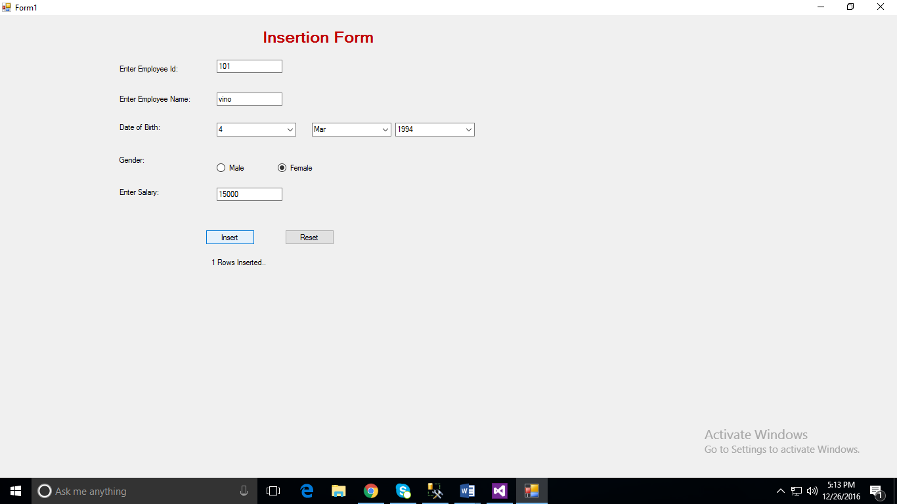  
using System;

using System.Collections.Generic;

using System.ComponentModel;

using System.Data;

using System.Drawing;

using System.Linq;

using System.Text;

using System.Threading.Tasks;

using System.Windows.Forms;

using System.Data.SqlClient;

namespace ADOPrograms

{

public partial class Form1 : Form

{

SqlConnection con;

SqlCommand cmd;

public Form1()

{

InitializeComponent();

}

private void Form1_Load(object sender, EventArgs e)

{

for (int i = 1; i <= 31; i++)

comboBox1.Items.Add(i);

for (int i = 1980; i <= DateTime.Now.Year; i++)

comboBox3.Items.Add(i);

}

private void button1_Click(object sender, EventArgs e)

{

try

{

con = new SqlConnection("server=.;Initial Catalog=vino;Integrated Security=true");

con.Open();

cmd = new SqlCommand();

cmd.CommandText = "insert into employee values(@eid,@ename,@dob,@gender,@salary)";

cmd.Connection = con;

string s = comboBox1.Text + "-" + comboBox2.Text + "-" + comboBox3.Text;

string gender;

if (radioButton1.Checked)

gender = "Male";

else

gender = "Female";

cmd.Parameters.AddWithValue("eid", textBox1.Text);

cmd.Parameters.AddWithValue("ename", textBox2.Text);

cmd.Parameters.AddWithValue("dob", s);

cmd.Parameters.AddWithValue("gender", gender);

cmd.Parameters.AddWithValue("Salary", textBox3.Text);

int i = cmd.ExecuteNonQuery();

cmd.Dispose();

con.Close();

label6.Text = i + " Rows Inserted..";

}

catch (Exception ex)

{

label6.Text = ex.Message;

}

}

private void button2_Click(object sender, EventArgs e)

{

textBox1.Text = null;

textBox2.Text = "";

textBox3.Text = "";

comboBox1.SelectedIndex = -1;

comboBox2.SelectedIndex =-1;

comboBox3.SelectedIndex = -1;

radioButton1.Checked = false;

radioButton2.Checked = false;

label6.Text = "";

}

}

}

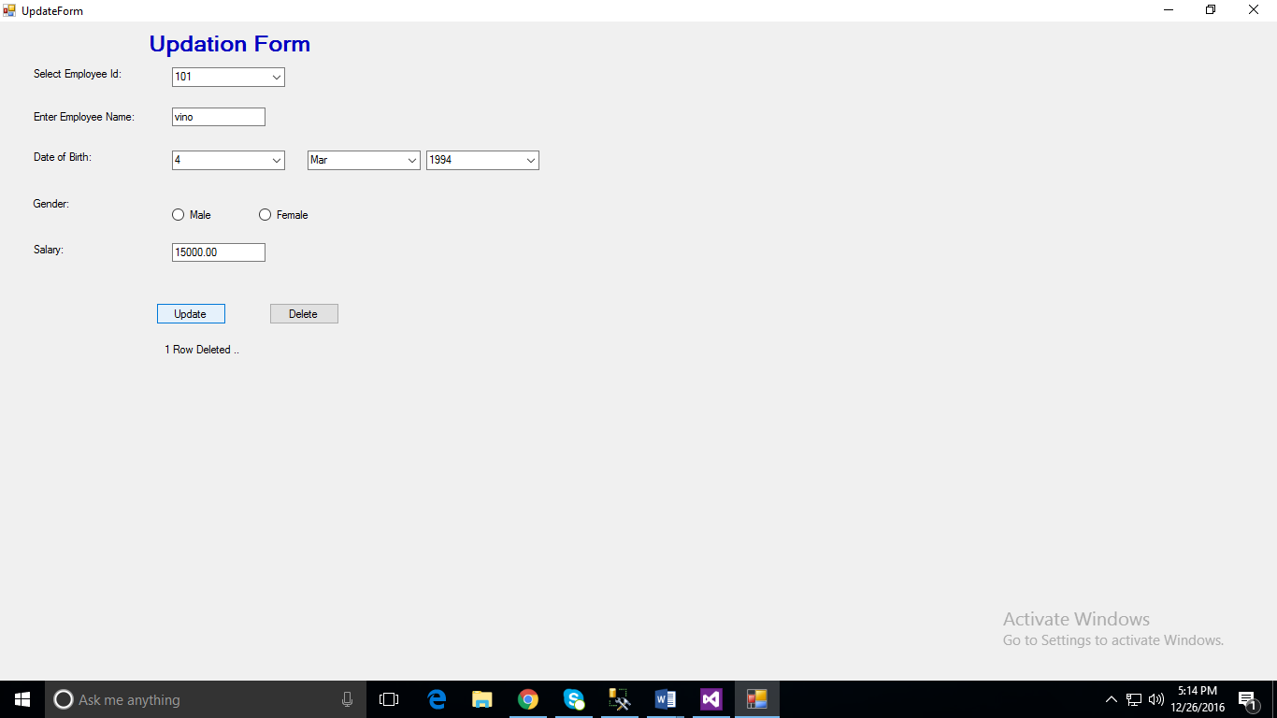

using System;

using System.Collections.Generic;

using System.ComponentModel;

using System.Data;

using System.Drawing;

using System.Linq;

using System.Text;

using System.Threading.Tasks;

using System.Windows.Forms;

using System.Data.SqlClient;

namespace ADOPrograms

{

public partial class UpdateForm : Form

{

SqlConnection con;

SqlCommand cmd;

SqlDataReader rs;

public UpdateForm()

{

InitializeComponent();

}

private void UpdateForm_Load(object sender, EventArgs e)

{

for (int i = 1; i <= 31; i++)

comboBox1.Items.Add(i);

for (int i = 1980; i <= DateTime.Now.Year; i++)

comboBox3.Items.Add(i);

//cmd = new SqlCommand();

//cmd.CommandText = "select eid from employee";

//cmd.Connection = con;

con = new SqlConnection("server=.;Initial Catalog=vino;Integrated Security=true");

con.Open();

cmd = new SqlCommand("select eid from employee",con);

rs=cmd.ExecuteReader();

while(rs.Read())

comboBox4.Items.Add(rs[0]);

rs.Close();

cmd.Dispose();

}

private void comboBox4_SelectedIndexChanged(object sender, EventArgs e)

{

try

{

cmd = new SqlCommand("select * from employee where eid=@eid", con);

cmd.Parameters.AddWithValue("eid", comboBox4.Text);

rs = cmd.ExecuteReader();

if (rs.Read())

{

textBox2.Text = rs["ename"].ToString();

DateTime dt = DateTime.Parse(rs["dob"].ToString());

comboBox1.Text = dt.Day.ToString();

comboBox2.Text = dt.ToString("MMM");

comboBox3.Text = dt.Year.ToString();

string gender = rs["gender"].ToString();

if (gender == "Male")

radioButton1.Checked = false;

else

radioButton2.Checked = false;

textBox3.Text = rs["salary"].ToString();

}

rs.Close();

cmd.Dispose();

}

catch (Exception ex)

{

label6.Text = ex.Message;

}

}

private void button1_Click(object sender, EventArgs e)

{

cmd = new SqlCommand("Update Employee set ename=@ename,dob=@dob,gender=@gender,salary=@salary where eid=@eid",con);

string s = comboBox1.Text + "-" + comboBox2.Text + "-" + comboBox3.Text;

string gender;

if (radioButton1.Checked)

gender = "Male";

else

gender = "Female";

cmd.Parameters.AddWithValue("ename", textBox2.Text);

cmd.Parameters.AddWithValue("dob", s);

cmd.Parameters.AddWithValue("gender", gender);

cmd.Parameters.AddWithValue("Salary", textBox3.Text);

cmd.Parameters.AddWithValue("eid", comboBox4.Text);

int i = cmd.ExecuteNonQuery();

cmd.Dispose();

label6.Text = i + " Row Deleted ..";

}

private void button2_Click(object sender, EventArgs e)

{

cmd = new SqlCommand("delete from employee where eid=@eid", con);

cmd.Parameters.AddWithValue("eid", comboBox4.Text);

int i = cmd.ExecuteNonQuery();

cmd.Dispose();

label6.Text = i + " Row Deleted ..";

textBox2.Text = "";

textBox3.Text = "";

comboBox1.SelectedIndex = -1;

comboBox2.SelectedIndex = -1;

comboBox3.SelectedIndex = -1;

comboBox4.SelectedIndex = -1;

radioButton1.Checked = false;

radioButton2.Checked = false;

}

}

}